Software Requirements Specification Template

STUDENT INFORMATION EXCHANGE ( IOS)

Software Requirements Specification

1.0

9/10/2023

Lalith Vuppala

Charishma Chowdary Bandaru

Pravallika Mummadi

Manohar Sri Vikram Vattikuti

Hemanth Yalamanchili

Jyothsna Naredla

Submitted in partial fulfilment.

Of the requirements of

CSIS 44-691 Graduate Directed Project 1

# Revision History

|  |  |  |  |
| --- | --- | --- | --- |
| **Date** | **Description** | **Author** | **Comments** |
| **<date>** | **<Version 1>** | **<Your Name>** | **<First Revision>** |
| 9/10/2023 | 1.0 | Lalith Vuppala | Introduction |
| 9/10/2023 | 1.0 | Charishma Chowdary Bandaru | General Description |
| 9/10/2023 | 1.0 | Pravallika Mummadi | External Interface Requirements |
| 9/10/2023 | 1.0 | Manohar Sri Vikram Vattikuti | Functional Requirements& Non-Functional Requirements |
| 9/10/2023 | 1.0 | Hemanth Yalamanchili | Inverse Requirements& Other requirements |
| 9/10/2023 | 1.0 | Jyothsna Naredla | Prototype |

# Document Approval

The following Software Requirements Specification has been accepted and approved by the following:

|  |  |  |  |
| --- | --- | --- | --- |
| **Signature** | **Printed Name** | **Title** | **Date** |
| Lalith Vuppala | Lalith Vuppala | Organizer module | 9/10/2023 |
| Charishma Chowdary Bandaru | Charishma Chowdary Bandaru | User Module | 9/10/2023 |
| Pravallika Mummadi | Pravallika Mummadi | User Module | 9/10/2023 |
| Manohar Sri Vikram Vattikuti | Manohar Sri Vikram Vattikuti | Organizer module | 9/10/2023 |
| Hemanth Yalamanchili | Hemanth Yalamanchili | Organizer module | 9/10/2023 |
| Jyothsna Naredla | Jyothsna Naredla | User Module | 9/10/2023 |

**Table of Contents**

**Table of Contents Page Number**

1. Introduction
   1. Purpose
   2. Scope
   3. Definitions, Acronyms, and Abbreviations
   4. References
   5. Overview
2. General Description
   1. Product Perspective
   2. Product Functions
   3. User Characteristics
   4. General Constraints
   5. Assumptions and Dependencies
3. Specific Requirements
   1. External Interface Requirements
      1. User Interfaces
      2. Hardware Interfaces
      3. Software Interfaces
      4. Communications Interface
   2. Functional Requirements
   3. Use Cases
   4. Class/Objects
   5. Non-Functional Requirements

3.5.1. Performance

3.5.2. Reliability

* + 1. Availability
    2. Security
    3. Portability
  1. Inverse Requirements
  2. Design Constraints
  3. Logical Database Requirements
  4. Other Requirements
  5. Prototypes (for complete project)
  6. Use Case Diagrams

1. Design

4.1. ER diagram.

4.2. GUI

1. Analysis Models

4.1. Data Flow Diagram

4.2. Sequence Diagram

1. **Introduction**

The Transition to studying at a university abroad brings with it a multitude of challenges, Uncertain, and new experiences. That’s where Student Information Exchange IOS steps in as your trusted guide. For Example, like make the transportation to international, education as smooth and enriching as possible. We understand the unique needs and concerns of students planning to study abroad, and our dedicated team of continuing and graduating students is here to offer their wisdom and assistance at every step of your journey. Whether you’re a new graduate looking to study at a foreign university, or someone seeking to provide teacher feedback, arrange transportation, navigate the certification process, or simply find essential amenities like housing, we’ve got you covered. Our platform serves as a comprehensive resource for all your academic, practical, and personal needs.

**1.1. Purpose**

The Purpose of Student Information Exchange IOS (International student outreach and support) is to help students who are planning to study at universities abroad. Continuing and graduating students will guide new students who want to study at this university, like teacher feedback, rides, help with the certification process and more, and finding housing. Provide feedback on study materials and travel locations if anyone wants to travel to nearby locations, etc.

**1.2 Scope**

The Scope of the student information IOS (International student outreach and support) system is to intercept information about students who are attending the university and details about the university which includes the application process and such as accommodation and feedback from previous students about the faculty and trips from various locations to the university. This will help students better understand the university, surroundings, neighbors, etc.

* 1. **Definitions, Acronyms, and Abbreviations**
* **Accommodation:** The users can search for available housing, using this interface, which displays location, price range, and utilities available
* **Cross-device compatibility:** The ability of the system to be responsive and adaptable to various screens and resolutions, whether on PCs, laptops, tablets, or smartphones. It ensures that the system's interface and features work effectively across a wide range of devices, providing a consistent user experience regardless of the device being used.
* **Ride booking Management:** The students have the option to request rides for airport pickups and trips to shopping destinations like Walmart, ensuring convenient transportation for various needs.
* **Marketplace Management:** The users will be able to search for old or used items, cars and other home utensils.

**1.4 References**

* **Yocket.com:** This platform that allows users to talk with the students at different universities Available on IOS and Android. <https://yocket.com/>
* **WeMakeSchollars:** This website will provide the loan process for students to study abroad, and students can interact with mentors. <https://www.wemakescholars.com/>

**1.5 Overview**

The following document outlines the key components of the Student Information IOS program, designed to aid students planning to study at universities abroad. This comprehensive program offers a wide range of services, from mentorship and cultural integration to academic support and safety guidelines.

**2.1. Product Perspective**

The "Student Information Exchange" project is a platform that has been integrated to give students access to a wide range of needs and services. Students may use it as a central location to arrange transportation, find accommodations, learn about upcoming events, get help with certifications, handle transcript requests, shop for used goods, get groceries, make phone conversations, and organize trips. To improve user experience and accessibility, the project will incorporate map services, a live chat function, user registration, and login functions. The app does not replace existing systems but integrates with them to provide a more convenient and mobile-friendly experience for users.

**2.2. Product Functions**

The iOS application offers a wide range of functions:

* **User Registration and Login:** The application allows students to register and create accounts securely, enabling them to log in and access the full range of features and services.
* **Accommodation Search:** Thestudents can easily search for available on-campus and off-campus accommodation, simplifying the process of finding suitable living arrangements.
* **Marketplace (Textbook and Material) Exchange:** The platform facilitates the exchange of textbooks, study materials, and furniture, promoting resource sharing within the student community.
* **Rides:** Thestudents have the option to request rides for airport pickups and trips to shopping destinations like Walmart, ensuring convenient transportation for various needs.
* **Events Information:** Theusers receive regular updates and information about campus events, parties, and social gatherings, helping them stay informed and engaged in campus life.
* **Document Services Assistance:** The application provides valuable support for university-related processes, including assistance with certification requests and guidance on various aspects of the academic journey, such as transcript handling and document submission.
* **Live Chat:** The users can engage in real-time chat conversations with fellow students, faculty, or staff, facilitating quick and efficient communication within the educational community.
* **Search Functionality:** The application includes a robust search feature that allows users to find specific information, services, or items quickly and efficiently they need.
* **Map Services:** Themap services are seamlessly integrated into the application, enabling users to access location-based functionalities.

**2.3. User Characteristics**

The "Student Information Exchange (IOS)" app caters to a diverse user base within educational institutions, including:

* **Students**: The primary user group consists of students from diverse educational backgrounds, including universities, colleges, and schools. These students are typically tech-savvy and use the application to access services, connect with peers, and simplify various aspects of their academic and daily lives.
* **Prospective Students**: The individuals considering enrollment in educational institutions may use the application to gather information about accommodations, university processes, and campus events, aiding their decision-making process.
* **Alumni**: The former students who have graduated from educational institutions may continue to use the platform to provide resources and engage with current students. They play a role in the textbook and material exchange feature.
* **Faculty and Staff:** The faculty members and administrative staff access the application to share information about campus events and communicate with students regarding academic matters, events, and university processes.
* **Service Providers**: The third-party service providers, such as ride-sharing drivers and delivery personnel, use the application to offer their services to students, making transportation and shopping more convenient.

**2.4. General Constraints**

**Budgetary Constraints:** The project is constrained by a limited budget for both its development and ongoing maintenance.

**Compliance with University Policies:** The project must adhere to the policies and regulations set forth by the university, particularly in relation to data privacy and security.

**Cross-Device Compatibility:** The system must ensure compatibility across a variety of devices and web browsers to maximize accessibility for users.

**Data Availability:** The project's functionality relies on the availability of essential data, particularly for mapping and event information, which must be accessible and up to date to provide accurate services.

**2.5. Assumptions and Dependencies**

Assumptions:

1. The students and users actively share and exchange information and resources within the educational community.
2. The data provided by users, like their profiles and academic records, is accurate and truthful.
3. The users will follow our rules about data privacy, and we'll follow the laws that protect their data.
4. The technical stuff like servers and networks we use will work well and won't cause problems.
5. The processes to make sure that the content users share follows our rules.

Dependencies:

1. **Availability of Accommodation and rides:** System depends on the availability of housing and rides to meet the demand of Students. This requires effective management and scheduling.
2. **User Engagement**: Success hinges on active user participation from students, educators, and others.
3. **Regulatory Compliance:** Adherence to data privacy and educational regulations is crucial.

**3. Specific Requirements**

**3.1. External Interface Requirements**

**3.1.1. User Interfaces**

* **Login User Interface:** This interface explains when users access the website, they will all be directed to a uniform page that requests their username and password.
* **User Profile Interface:** This interface explains that once they are verified with the correct username and password, users will be redirected to their individual profiles where they can engage in various actions.
* **Rides Interface:** This interface enables users to find rides for their travel needs. This interface provides fields for users to provide their Pickup and Destination points, along with the date and time of the ride. Also, this shows a comprehensive list of accessible rides, showcasing driver details, cost-sharing options, and departure schedules.
* **Accommodations Interface:** This interface enables users to search for available accommodation, which shows location, price range, and utilities available.
* **Events Interface:** This interface lists upcoming events and parties on or near the campus. Also allows users to get event details.
* **Document Services Interface**: This interface Facilitate academic-related assistance by offering guidance on university processes like course registration, graduation requirements, and document services. Provides links to necessary forms. Enable users to know the process for transcripts and academic documents requests.
* **Marketplace Interface:** This interface helps to create a marketplace for buying or selling old textbooks, furniture, and other items.

**3.1.2. Hardware Interfaces**

No additional hardware interfaces are required. This app will have the standard hardware resources.

**3.1.3. Software Interfaces**

The Software tools used are Xcode with IOS version of 14 or any higher versions. The Devices can be a MacBook, Apple iPhone, iPad etc.

**3.1.4. Communications Interfaces**

* **Live Chat Communication:** This enables users to engage in real-time text-based conversations within the app with a live chat option.
* **Phone Call Communication:** This allows users to make voice calls to each other directly.
* **Email Communication:** This allows users to exchange emails within the app.

**3.2. Functional Requirements**

* **User Registration and Authentication:** Allows users forRegistration using distinct usernames and email addresses. Also provides password reset functionality and secure login.
* **User Roles and Permissions:** Defines user roles and the corresponding permissions (admin, user, manager, etc.).
* **User Profile Management:** Permits users to edit their profiles, which should include preferences and personal data.
* **Accommodation Search and Selection:** Provides a user-friendly interface for customers to search for available accommodations based on location, price, and other preferences. Display relevant details such as Housing specifications, pricing, availability, and leasing or rental terms.
* **Ride Booking Management:** Enables users to select a ride, choose destination and pickup, and make reservations securely. Allow users to manage their bookings, including modifications, cancellations, and extensions. This has a map feature to see the ride pickup and destination points.
* **Events Management:** Enables users to get the event details happening on the campus. Users can chat and get to know more details in-person.
* **Marketplace Management:** Enables users to search for old or used stuff like textbooks, furniture, or any resources etc.
* **Search and Filtering:** Gives users the option to search and filter data using a variety of criteria.
* **Notifications:** Users should receive notifications of pertinent events or upgrades.
* **Messaging and Communication:** Implements message, chat, and email tools to encourage user contact.

**3.3. Use Cases**

* **User Registration:** Scenario of this Step

1. Go to the registration page using the browser.
2. The user chooses a username and password and enters personal information.

**Outcome:** A confirmation email is received after the creation of the user account.

* **User Login:** Scenario of this Step

1. On the login screen, users enter their username and password.
2. User selects "Login" from the menu.

**Outcome:** Access to the user's account dashboard is granted.

* **Rides**: Scenario of this Step

1. Users enter pickup, destination, time, and date for pickup in the designated fields.
2. Users can talk to the people available.
3. Confirm or deny the request.

**Outcome:** User finds ride to go.

* **Accommodations:** Scenario of this Step

1. Users can request accommodation.
2. Available accommodation can be posted in the application.
3. Users can view it from the available storyboard.
4. Users can communicate with the already staying roommates.

**Outcome:** Users can check-in to the temporary or permanent accommodation based on the chat they had.

* **Events and Party Information:**

1. Users can view events on the dashboard.
2. Details like time, place, event, details will be provided.

**Outcome:** Users can be the judge whether to attend or not to the event.

* **Document Services Assistance:**

1. Users can raise their doubts about certain processes.
2. A person with knowledge in that scenario can address the issue.

**Outcome:** Users leave with their doubts clarified so that they can focus on the next steps.

* **Marketplace for Old Items:**

1. Users can post items that they would like to sell in the application.
2. They post their contact information, price, photos of the item, and other relevant information.
3. Interested buyers can view the items and if they would like to proceed, they can contact the seller.

**Outcome:** Sale of certain items can be done.

**3.4. Class/Objects**

* **Login class:** This class represents login and has attributes such as email/phone no and password.
* **Registration class:** This class represents registration class and has attributes such as First Name, Last Name, Phone no, Email, Password.
* **Accommodation class:** This class includes attributes such as no. of members, address, date, temporary, or permanent stay options, Leasing option.
* **Events/party class:** This class represents events happening and includes details of events in university. Attributes included in this class are address, date, time.
* **Marketplace class:** This class represents the marketplace i.e., about the old stuff available and has attributes such as item, number of items, photos, address, price, and description.
* **Rides class:** This class represents the rides available and has includes attributes like pickup, destination.

**3.5. Non-Functional Requirements**

**3.5.1. Performance:**

* **Response Time:** Setting a time limit on how quickly the system must react to user events (such as page load times and query response times). It should usually take 60 secs for a task to show up.
* **Throughput:** Setting a limit on how many transactions or requests the system may process each second.

**3.5.2. Reliability:**

* **Availability:** Establish the percentage of time the system should be available to users and operating (for example, 99.9% uptime).
* **Fault Tolerance:** Describe how long the system can keep running after a hardware or software failure. Errors should be considerably low to have high performance.

**3.5.3. Availability:**

* **Uptime:** This system should strive for maximum uptime, ideally operating 24 hours a day, 7 days a week. It should be akin to your favorite online game, always up and running smoothly for users.
* **Downtime**: This system should avoid downtime, while downtime cannot always be avoided, it should be minimized. Any planned maintenance or system updates should be scheduled during off-peak hours to ensure minimal disruption and that should be around 1-3 hours to fix it.

**3.5.4. Security:**

* **Authentication and Authorization:** The subsystem should ensure a high level of data security and integrity by implementing stringent user authentication requirements and access control techniques, permitting access exclusively to authorized personnel with valid usernames and passwords.
* **Data Encryption:** The Robust data encryption standards and protocols must be integrated to protect sensitive information during transmission and storage, safeguarding it from unauthorized access or interception.
* **Compliance:** The Strict adherence to security norms and laws such as HIPAA is imperative to guarantee compliance and operate within the legal framework, thereby enhancing the overall security and reliability of the subsystem.

**3.5.5. Portability:**

* **Cross-Device Compatibility:** The ability of the system to be responsive and adaptable to various screens and resolutions, whether on PCs, laptops, tablets, or smartphones. It ensures that the system's interface and features work effectively across a wide range of devices, providing a consistent user experience regardless of the device being used.
* **Browser Compatibility:** The web-based systems, the program should run without any rendering problems across a variety of web browsers, such as Chrome, Firefox, Safari, and Edge.
* **Mobile Responsiveness:** This is relevant for mobile applications, where the user interface should be optimized for mobile devices. It involves creating a smooth and tailored user experience on smartphones and tablets, considering differences in screen sizes and resolutions. Mobile responsiveness ensures that the application adapts seamlessly to various mobile devices, enhancing user satisfaction.

**3.6 Inverse Requirements:**

* The system should not allow unauthorized access to student's data, such as their student id and their email ids.
* The system shouldn't be challenging to use or navigate, and users shouldn't need a lot of training to learn how to utilize it.

**3.7 Design Constraints:**

* **User interface constraints:** This system must be designed with a user-friendly interface that is easy to navigate and use.
* **Security constraints:** This system must be built with strong security features that guard against cyberattacks and prevent unauthorized access to sensitive data.

**3.8 Logical Database Requirements:**

* **User Information**: The User data, including name, phone number, and email address, must be stored by the system.
* **University Information:** The system must store information about each university, including its ranking, location etc.
* **Rides Information:** The users will be able to find rides for their travel needs. This interface provides fields for users to provide their Pickup and Destination points, along with the date and time of the ride. Also, this shows a comprehensive list of accessible rides, showcasing driver details, cost-sharing options, and departure schedules.
* **Accommodations Information:** The users can search for available housing, using this interface, which displays location, price range, and utilities available.
  1. **Other Requirements:**
* **Security and Data Privacy:** The system must ensure the security of customer and business data, including personal information. Compliance with data protection regulations like HIPAA, where applicable, should be maintained.
* **Mobile-Friendly Interface:** The system should have a responsive design to ensure accessibility and ease of use on various devices, including smartphones and tablets.
  1. **Prototypes**
     1. **Login screen**

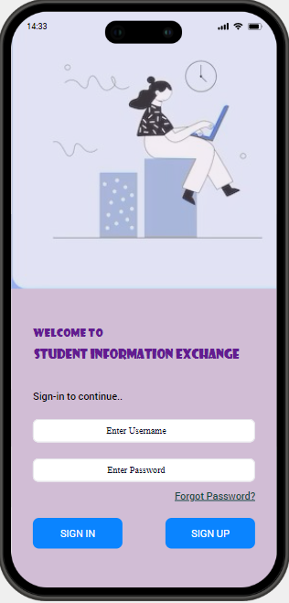

* + 1. **Sign-up screen**

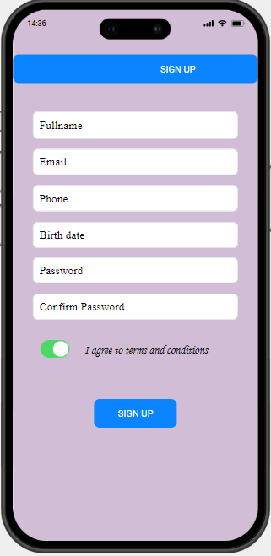

* + 1. **Forgot password screen**

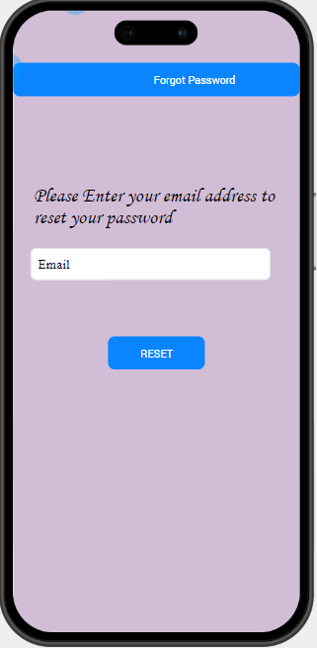

* + 1. **Reset password screen**

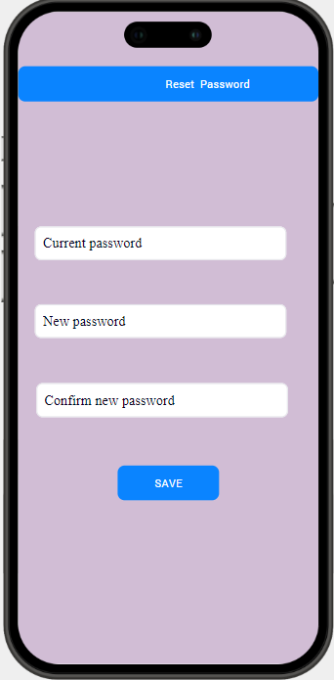

* + 1. **Home screen**

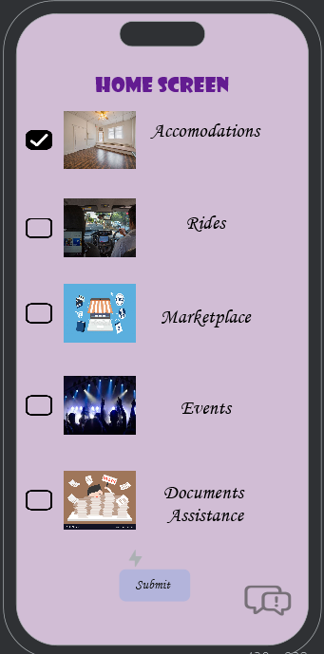

* + 1. **Accommodations details screen**

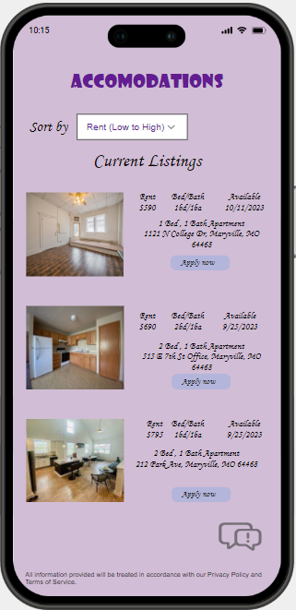

* + 1. **Accommodation booking screen.**

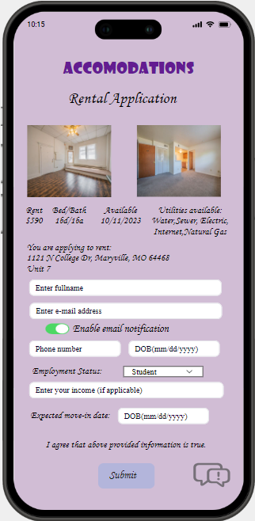

* + 1. **Accommodation booking successful screen.**

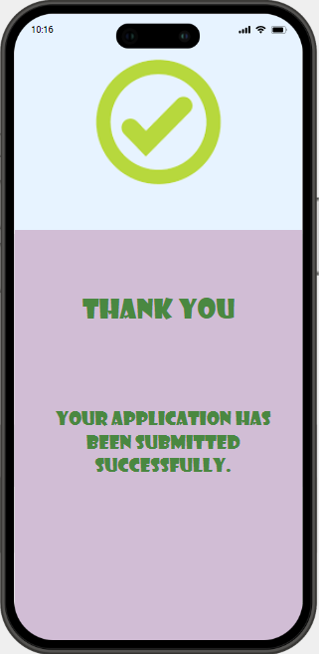

* + 1. **Accommodation posting screen.**

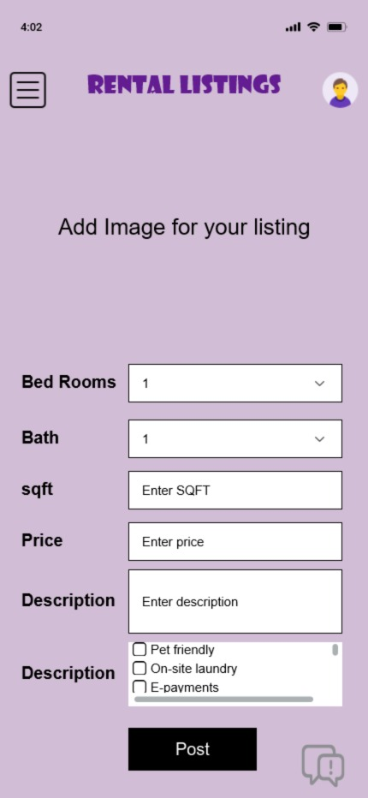

* + 1. **Rides Welcome Screen.**

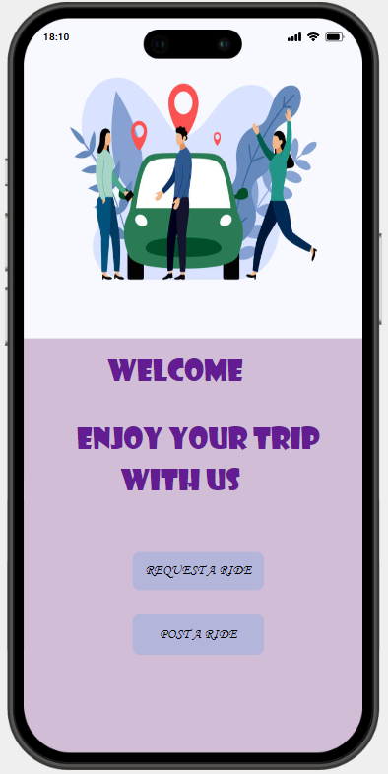

* + 1. **Ride Booking Screen & Post screen.**

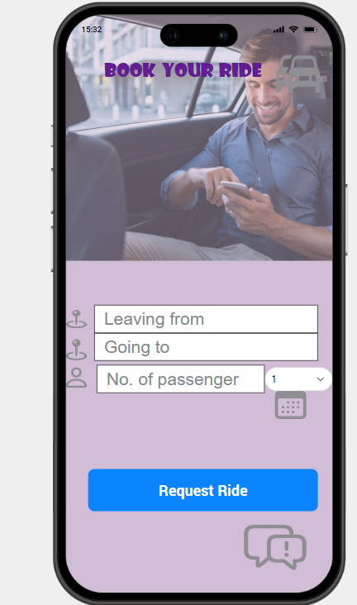 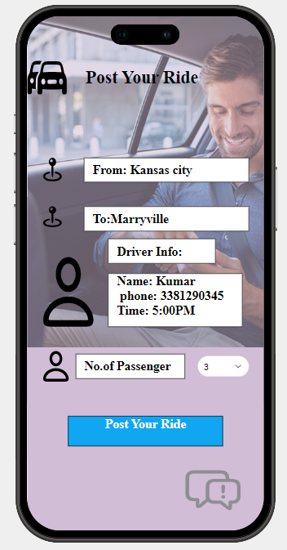

* + 1. **Route Screen**

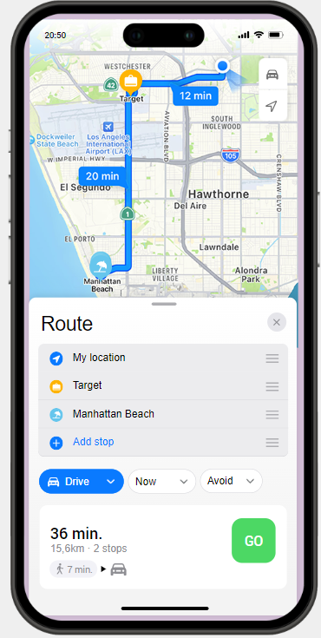

* + 1. **Payment Method Screen**

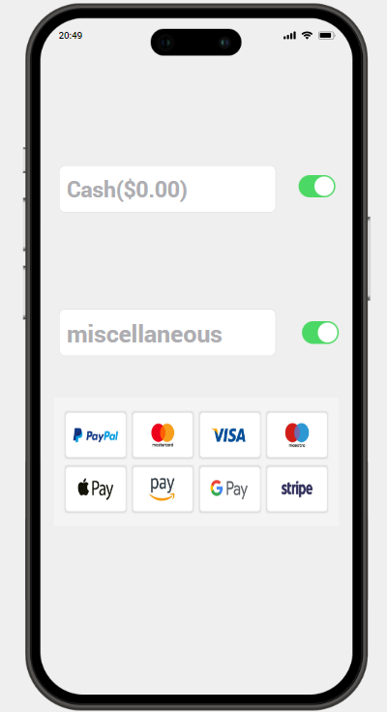

* + 1. **Ride Confirmation Screen**

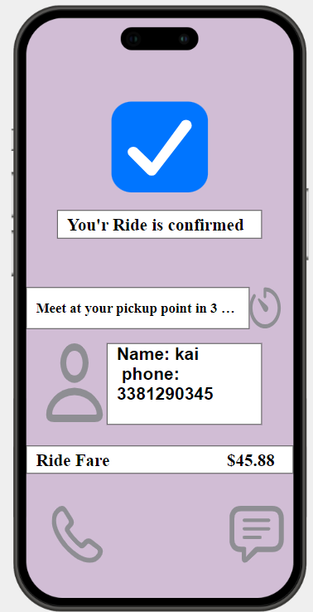

* + 1. **Marketplace Welcome Page**

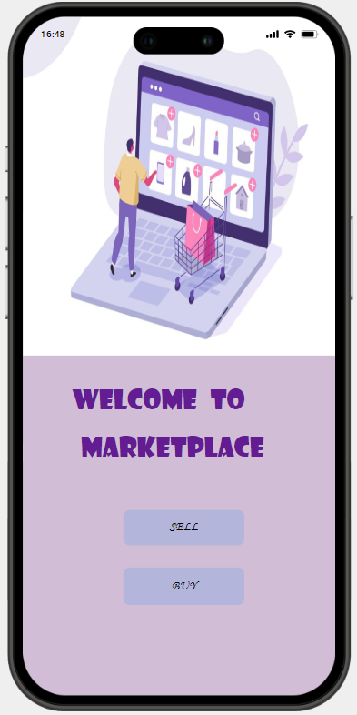

* + 1. **Marketplace Buyers Details Screen**

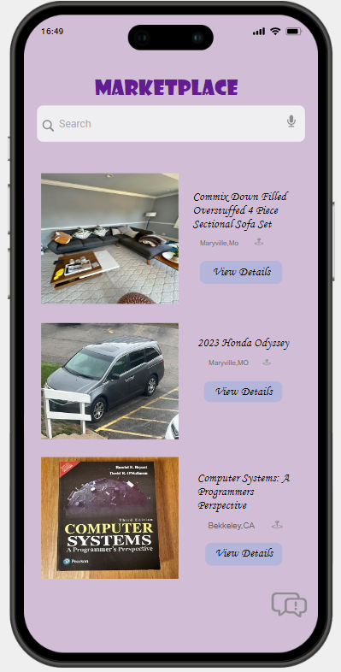 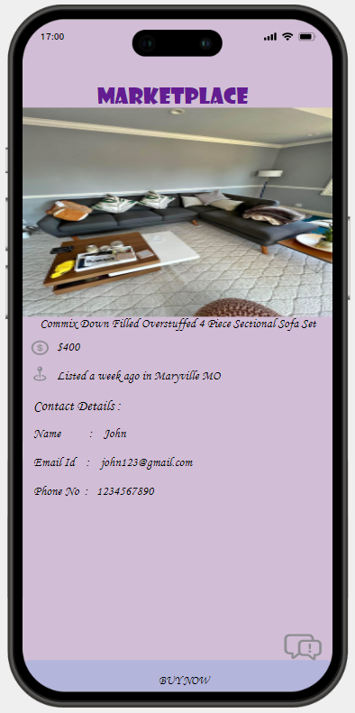

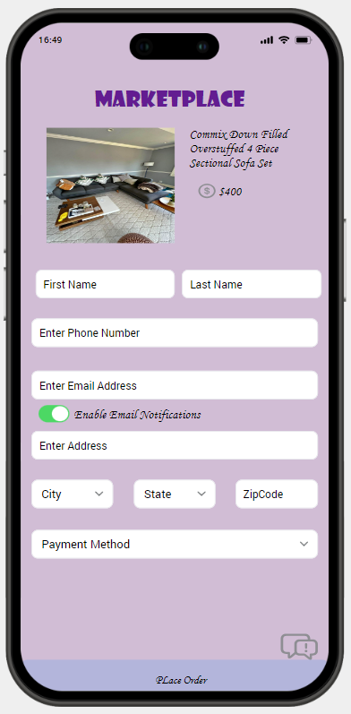

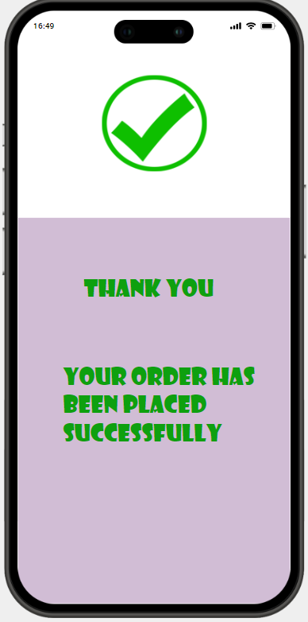

* + 1. 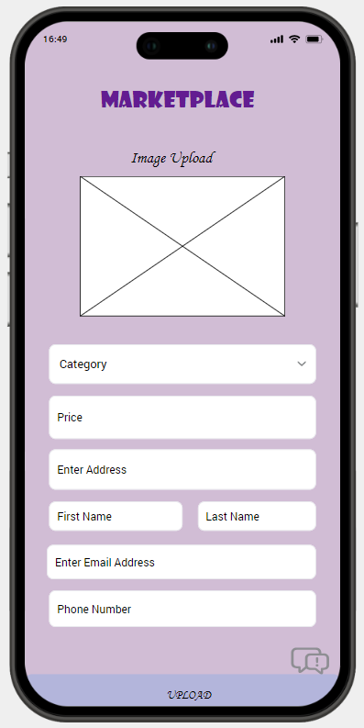**Products Seller screen.**

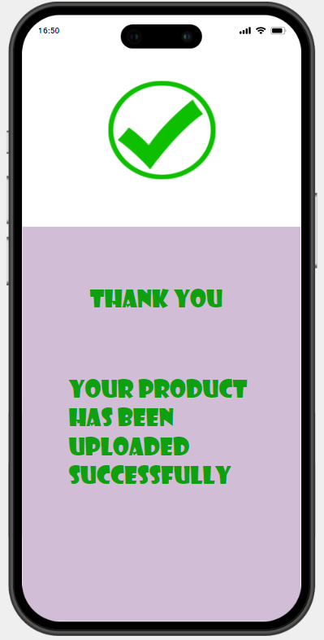

* + 1. **Event details screen**

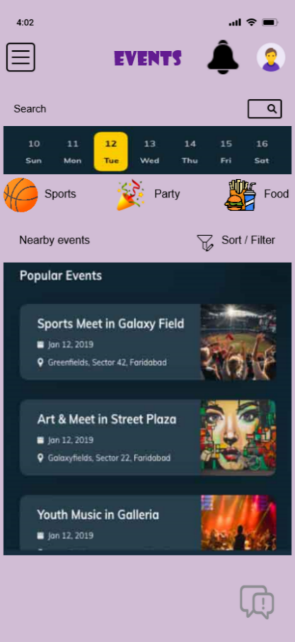

* + 1. **In detailed view of the event**

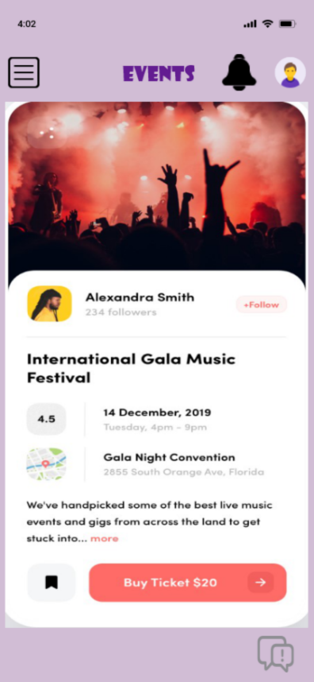

* + 1. **Ticket booking page for event**

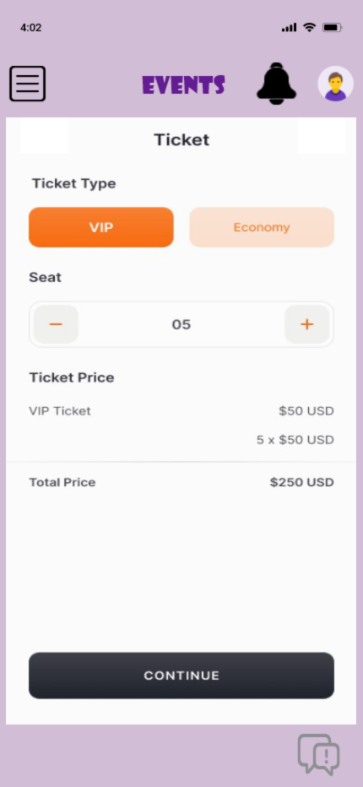

* + 1. **Final ticket for event**

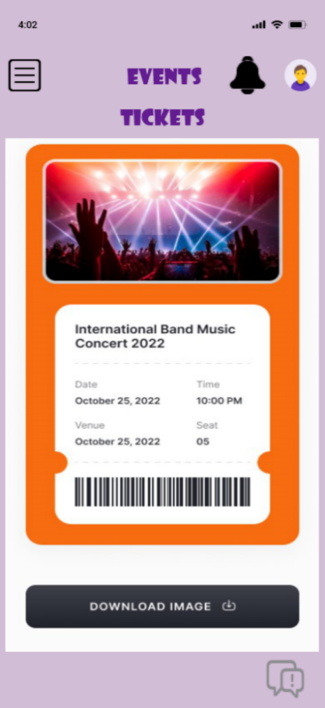

* + 1. **University documentation process screen**

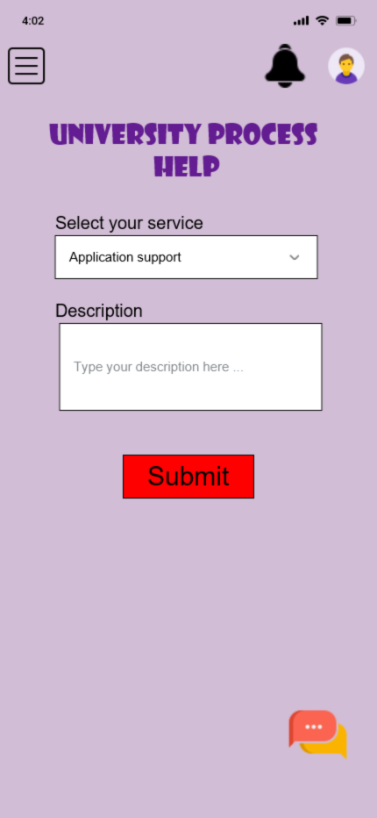

* + 1. **University certification page**

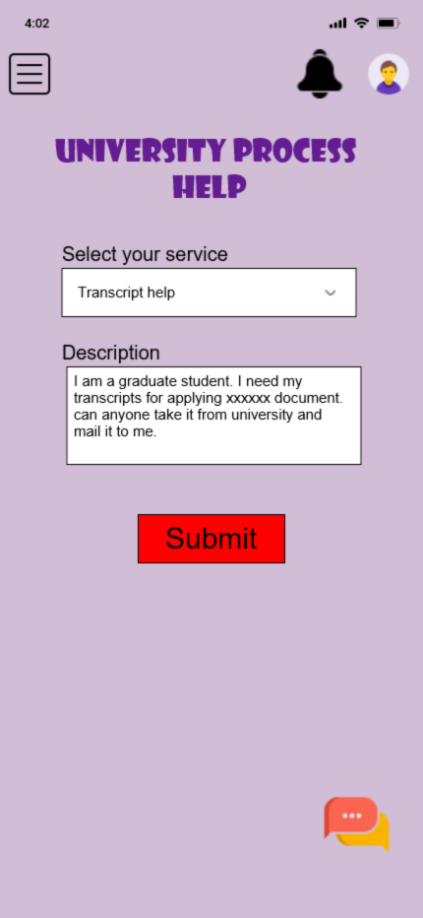

* + 1. **University certification page**

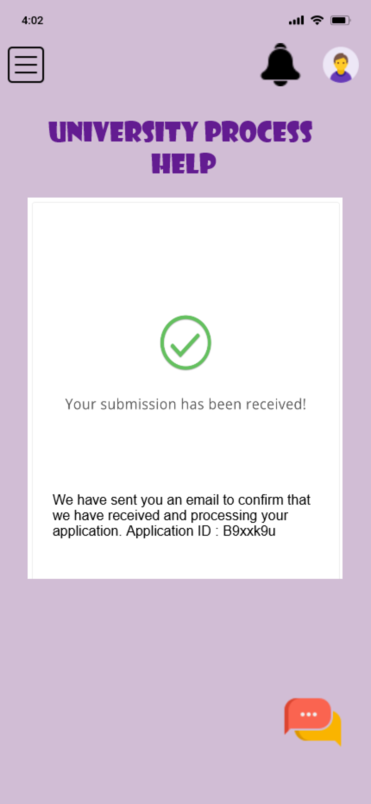

**4. Design**

**4.1. ER diagram**

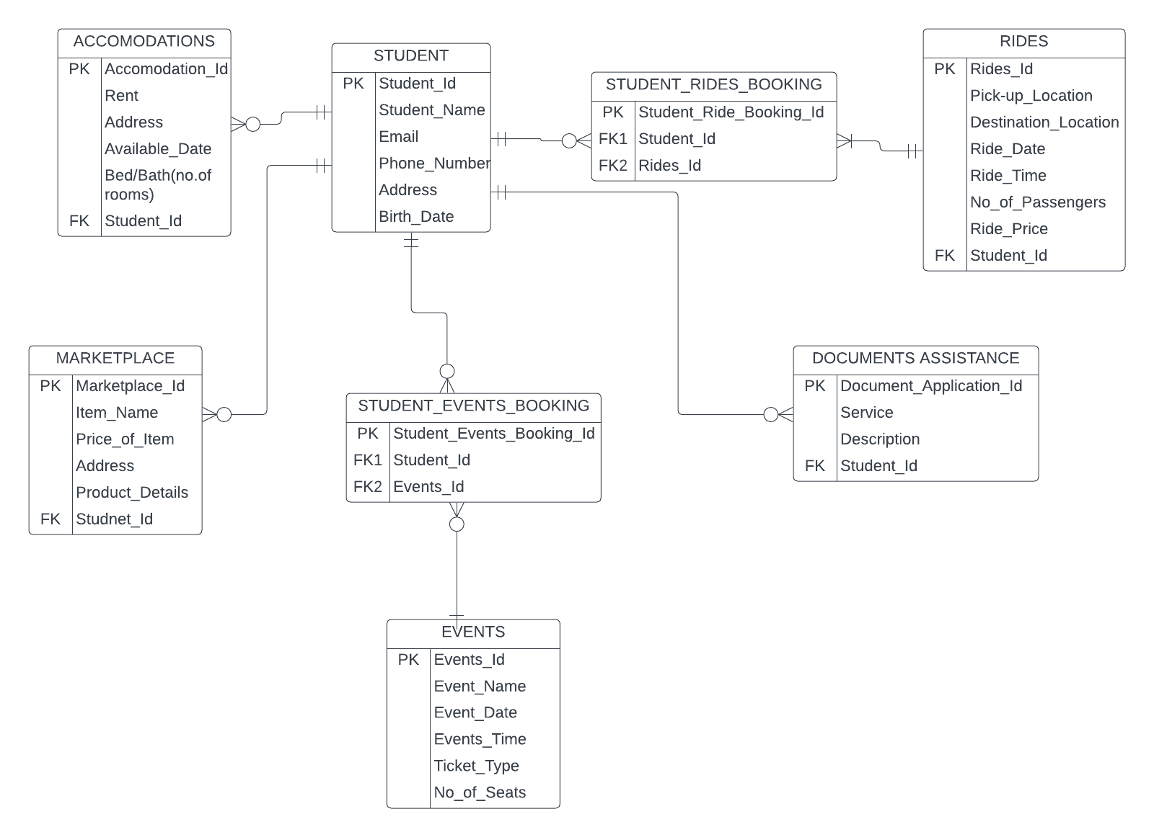

* In the above ER diagram, we have taken Entities as STUDENT,ACCOMODATIONS,RIDES,MARKETPLACE,DOCUMENTS ASSISTANCE,EVENTS and we have taken two associative entities named as STUDENT_EVENTS_BOOKING,STUDENT_RIDES_BOOKING.
* In the STUDENT entity, we have taken Student_id as primary key, and remaining attributes are Student_id,Student_Name,Email,Phone_Number,Address,Birth_Date.
* In the ACCOMODATIONS entity, we have taken Accomodation_Id as primary key, and remaining attributes are Rent,Address,Available_Date,Bed/Bath(no.of rooms) AND foreign key as Student_Id.
* In the RIDES entity, we have taken Rides_Id as primary key, and remaining attributes are Pick-up_Location,Destination_Location,Ride_Date,Ride_Time,No_of_Passengers Ride_Price and foreign key as Student_Id.
* In the MARKETPLACE entity, we have taken Marketplace_Id as primary key, and remaining attributes are Item_Name,Price_of_Item,Address and foreign key as Student_Id.
* In the DOCUMENTS ASSISTANCE entity, we have taken Document_Application_Id as primary key, and remaining attributes are Service,Description and foriegn key as Student_Id.
* In the EVENTS entity we have taken Events_Id as primary key, and remaining attributes are Event_Name,Event_Date,Time,Ticket_Type,No_of_Seats,Product_Details.
* Here we have given the relation between STUDENT and ACCOMODATIONS entity which has 1:M Relation And we have taken Student_Id as foreign key in the ACCOMOCATIONS because we must add foreign key on many side.
* And here we have given the relation between STUDENT and MARKETPLACE entity which has 1:M Relation And we have taken Student_Id as foreign key in the MARKETPLACE because we must add foreign key on many side.
* And here we have given the relation between STUDENT and DOCUMENTS ASSISTANCE entity which has 1:M Relation And we have taken Student_Id as foreign key in the DOCUMENTS ASSISTANCE because we must add foreign key on many side.
* Here we have changed Many to many relations into two 1:M Relations and added an associative entity named as STUDNETS_EVENTS_BOOKING between STUDENT,EVENTS entities where we have taken STUDNEST_EVENTS_BOOKING_Id as primary key and foreign keys are Student_Id and Events_Id.
* And we have changed Many to many relations into two 1:M Relations and added an associative entity named as STUDNETS_RIDES_BOOKING between STUDENT,RIDES entities where we have taken STUDNEST_RIDES_BOOKING_Id as primary key and foreign keys are Student_Id and Rides_Id.
* One student may or may not book or post many accommodations, So STUDENT has optional many relation with ACCOMODATIONS whereas one Accommodation can booked and posted by one student only, So ACCOMODATIONS has mandatory one relation with the STUDENT.
* One student may or may not book or post many rides, So STUDENT has optional many relation with RIDES whereas one ride must be booked by one or many students, So RIDES has mandatory many relation with the STUDENT.
* One student may or may not request or post many marketplace items ,So STUDENT has optional many relation with MARKETPLACE whereas one market place item can be requested to one STUDENT only, So MARKETPLACE has mandatory one relation with the STUDENT.
* One student may or may not request or post many documents assistance help, So STUDENT has optional many relation with DOCUMENTS ASSITANCE whereas One document’s assistance can be related to one STUDENT only, So DOCUMENTS ASSITANCE has mandatory one relation with the STUDENT.
* One student may or may not book or post many events, So STUDENT has optional many relation with EVENTS whereas one event may or may not be booked by one or many students, So RIDES has optional many relation with the STUDENT.
  1. **GUI**

**4.2.1 Student Information Exchange Screen**

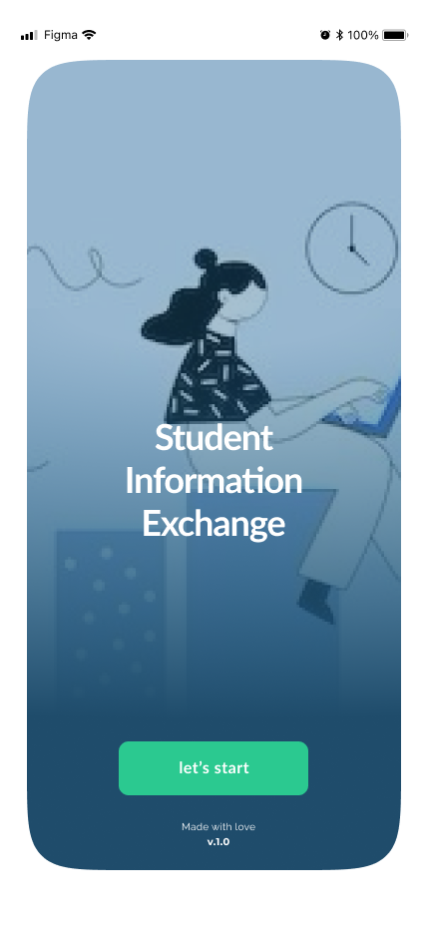

**4.2.2 Login Screen**

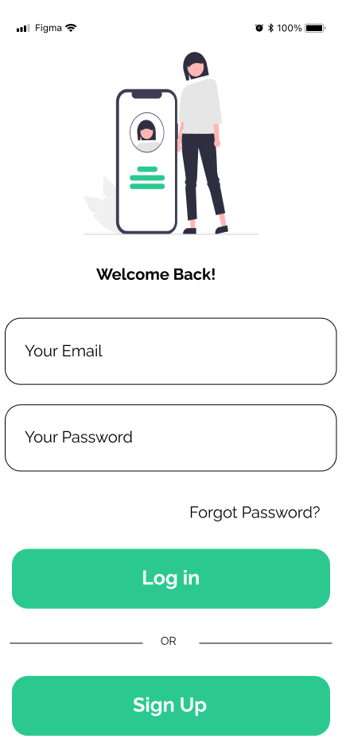

**4.2.3 Create Account Screen**

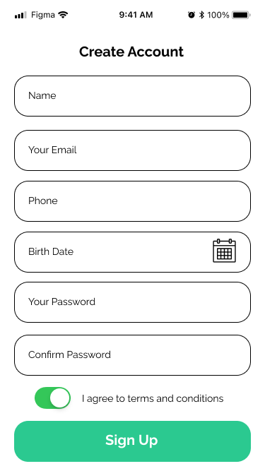

**4.2.4 Forgot Password**

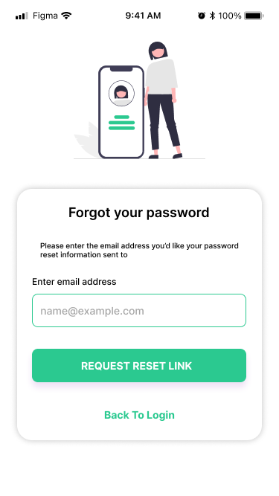

**4.2.5 Change Password**

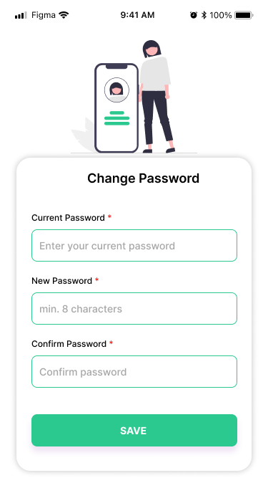

**4.2.6 Home page of the application**

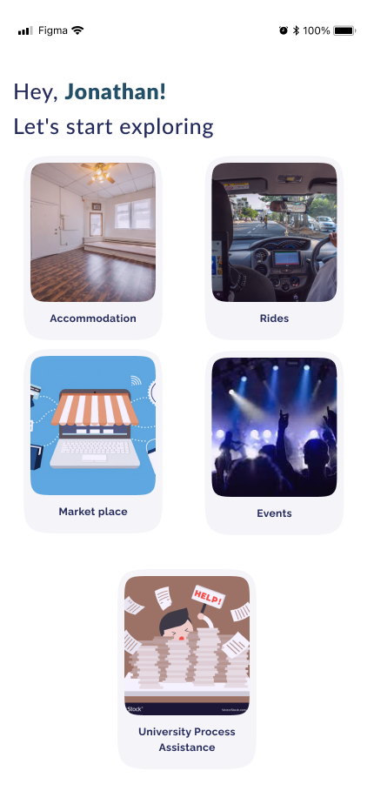

**4.2.7 Accommodation booking screens**

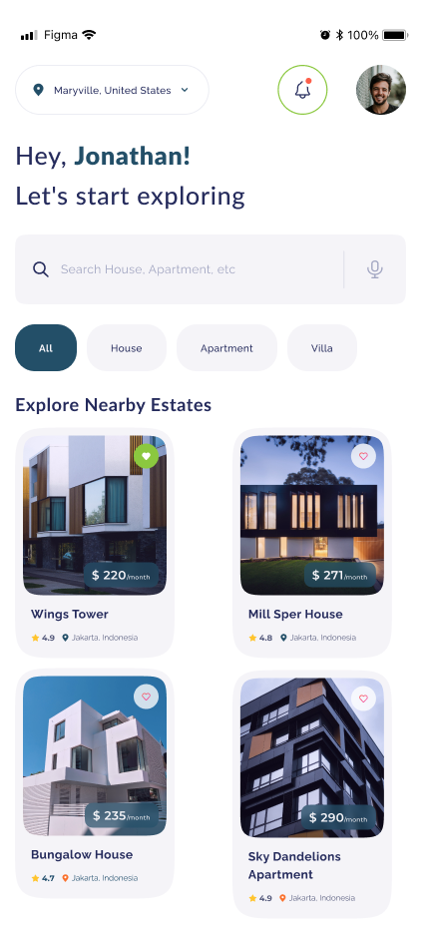

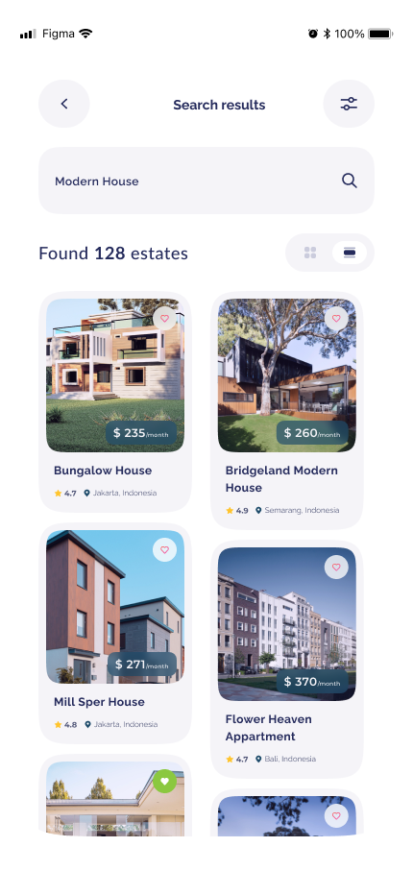

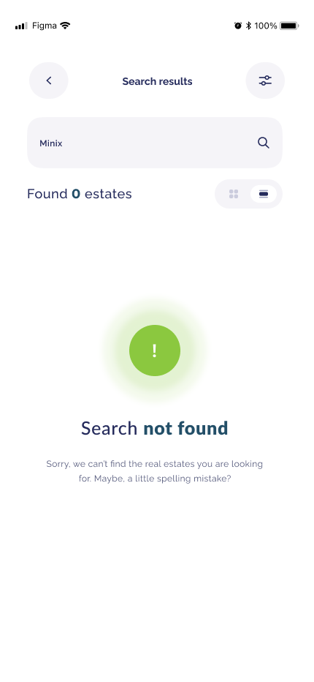

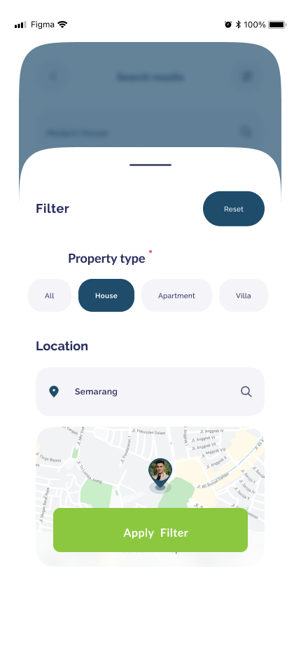

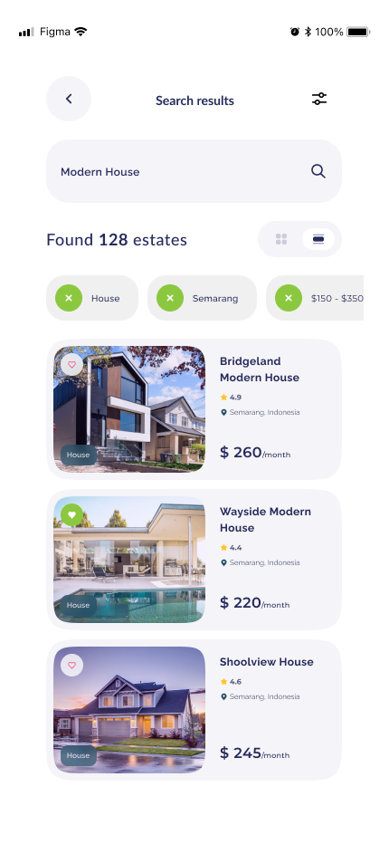

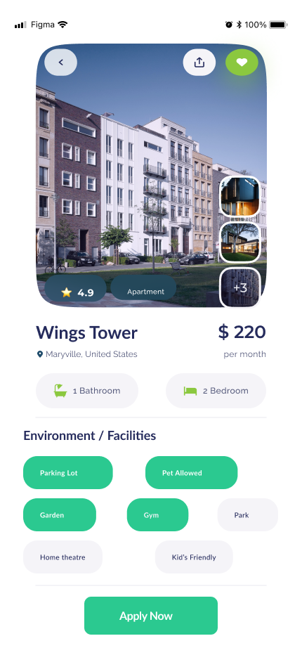

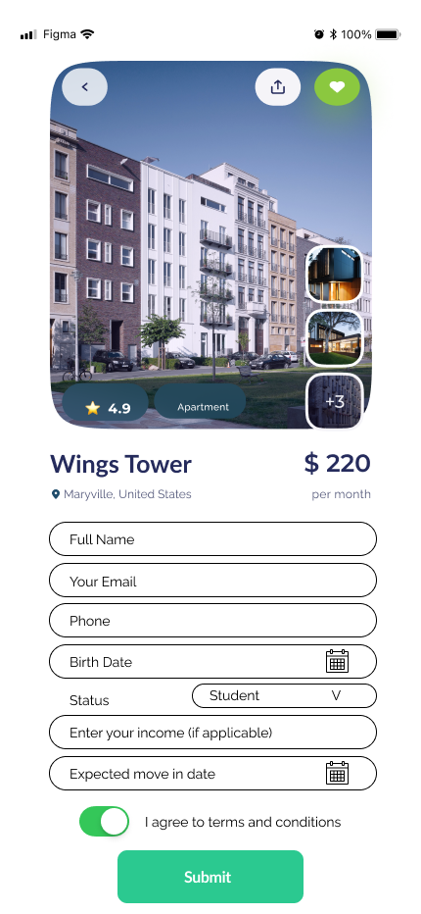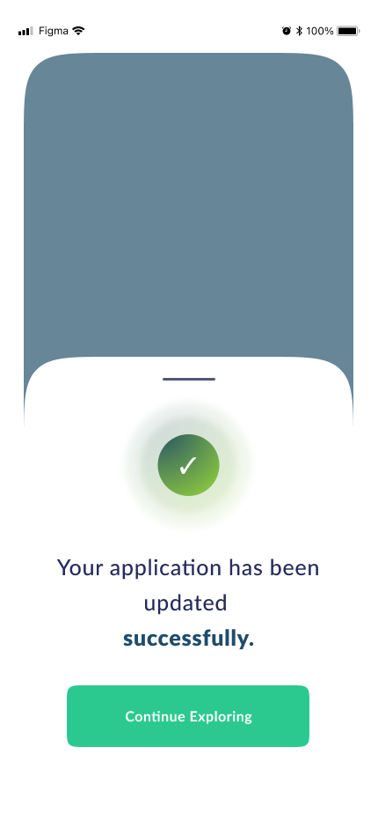

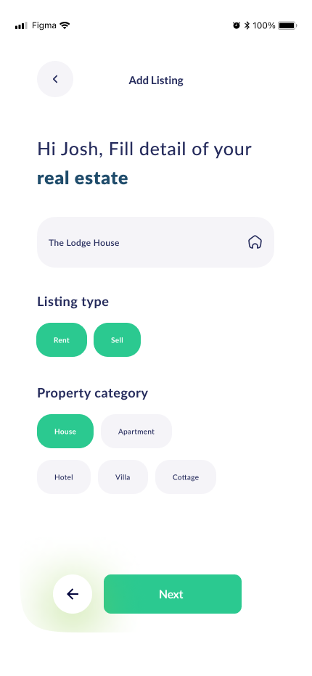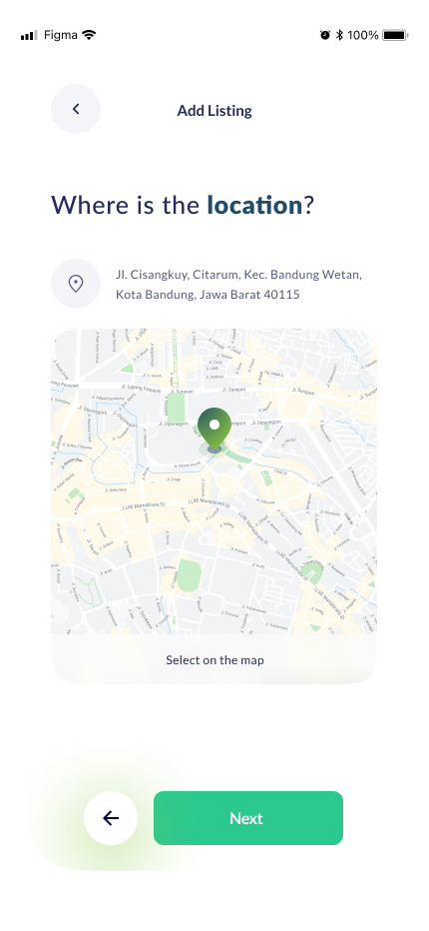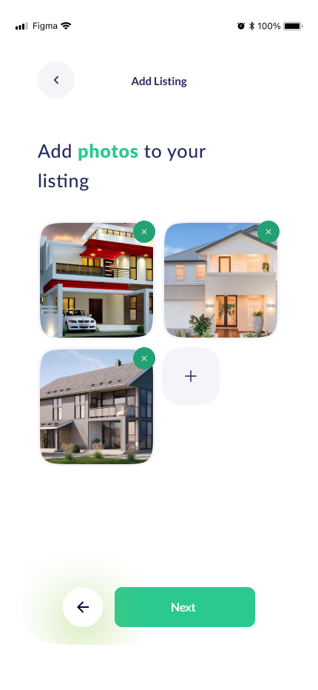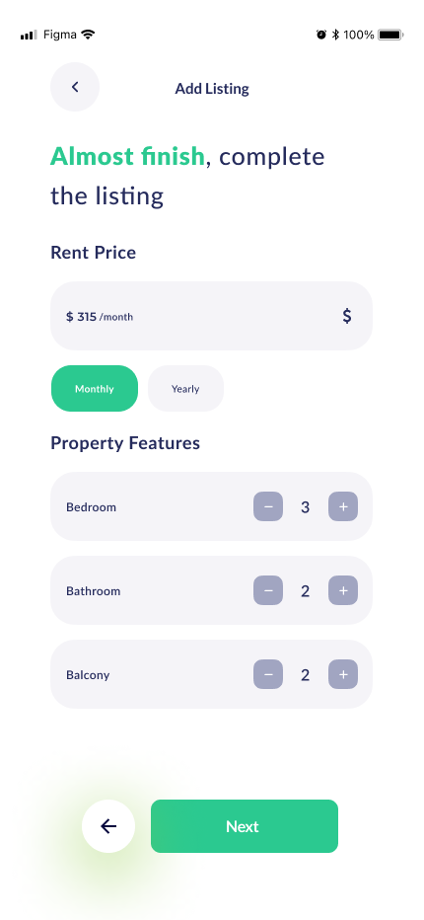

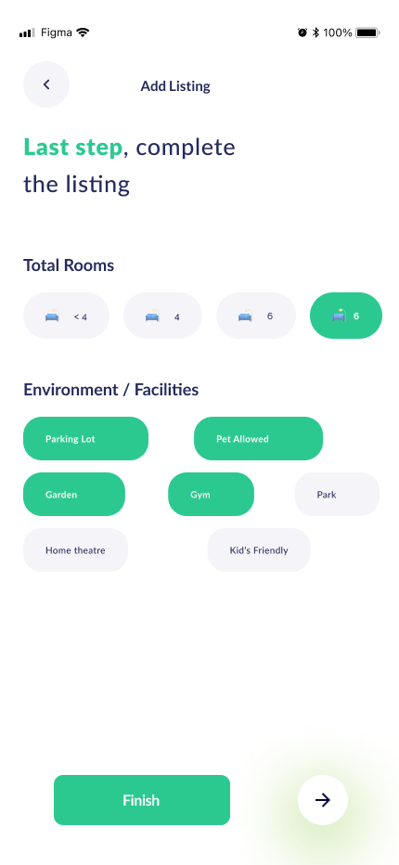

**4.2.8 Product Listings Buying Screens**

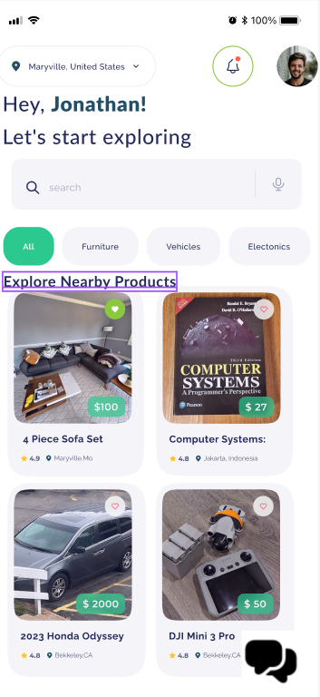 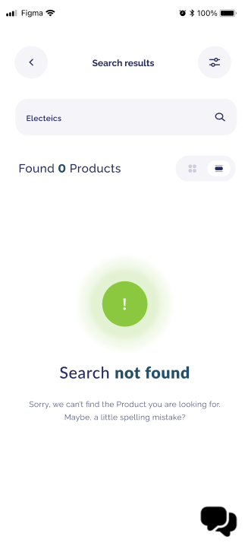

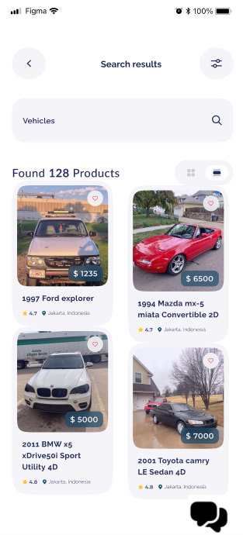 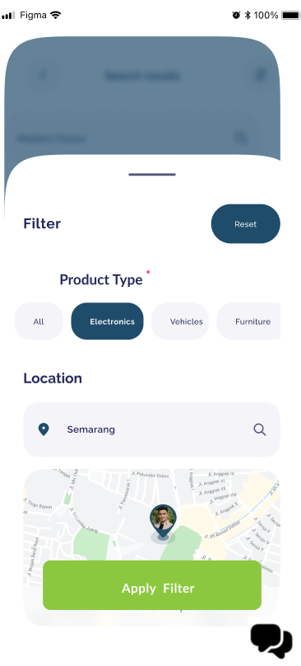 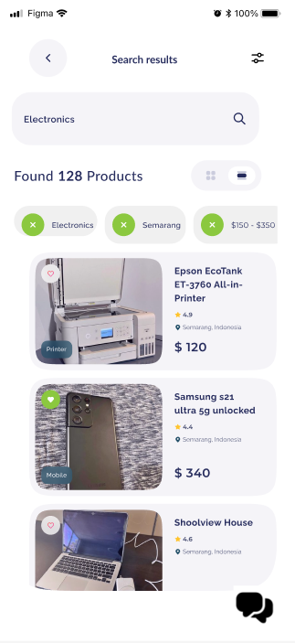 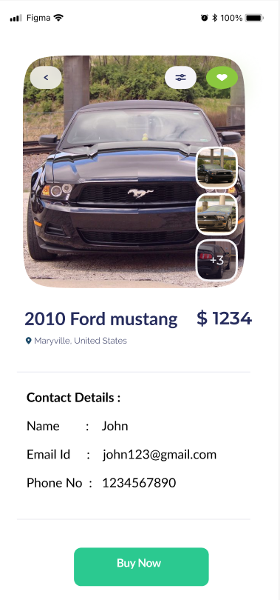 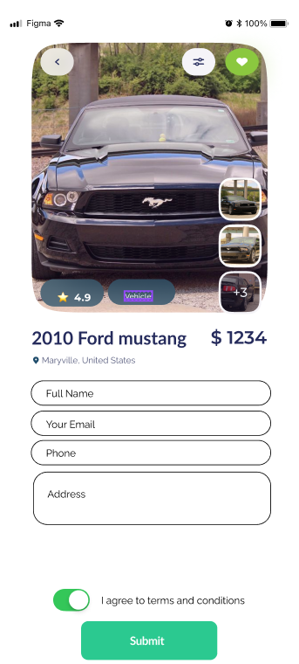 

**4.2.9 Product Listings Posting screens**

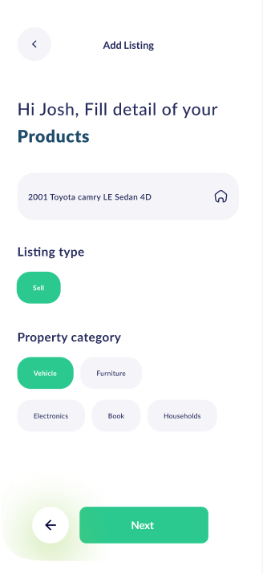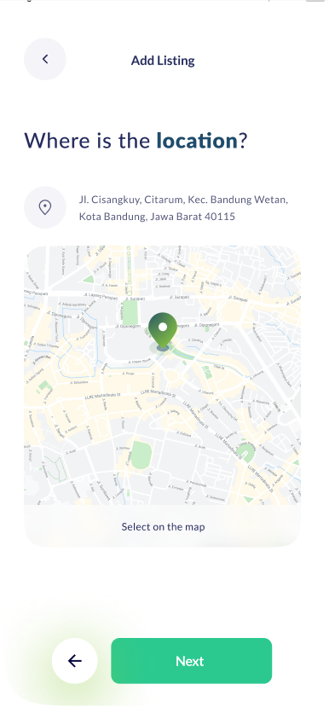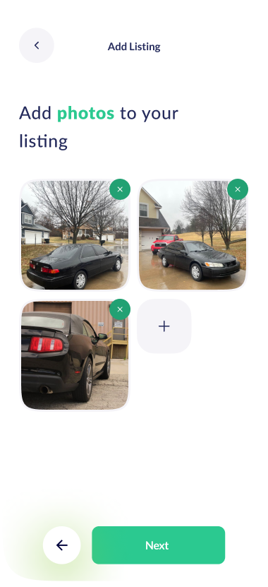

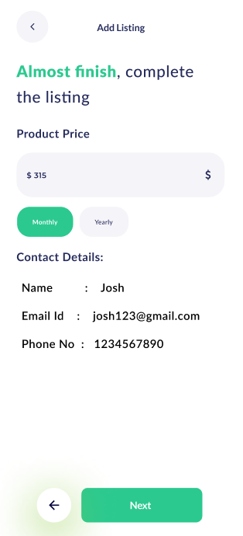

**4.2.10 Event home screen**

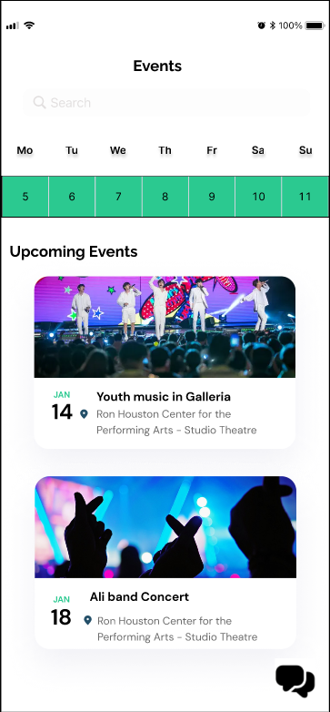

**4.2.11 Event details screen**

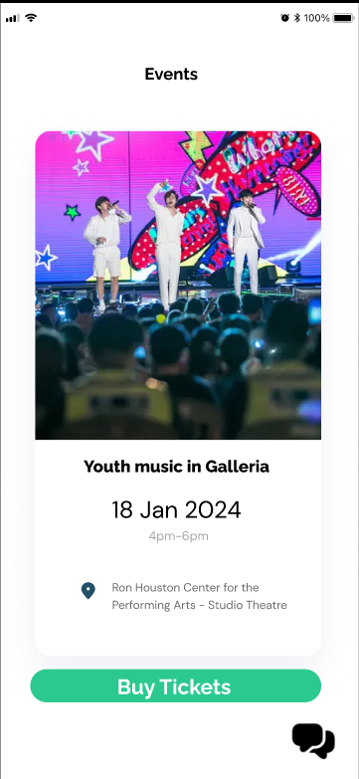

**4.2.12 Event ticket screen**

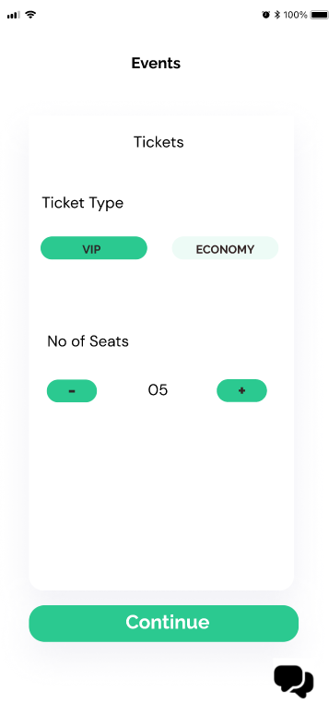

**4.2.13 Event booked screen**

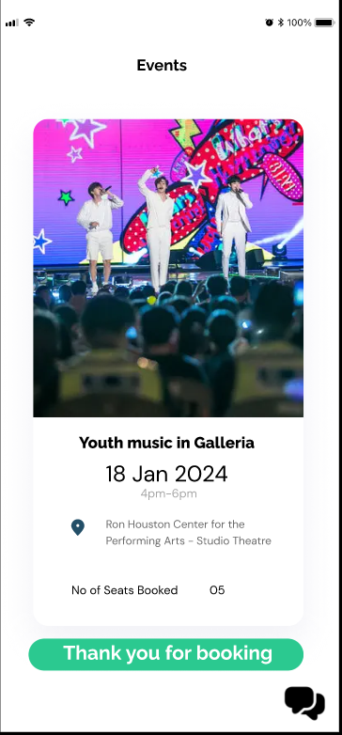

**4.2.14 Rides Booking Screen: -**

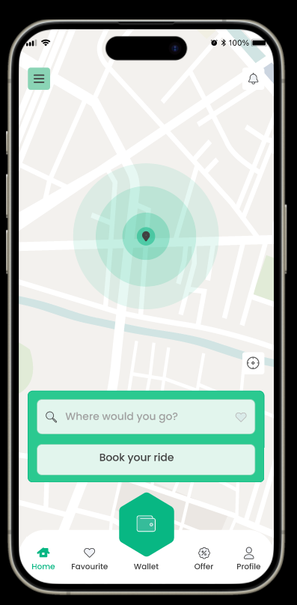

**4.2.15 Location Confirmation: -**

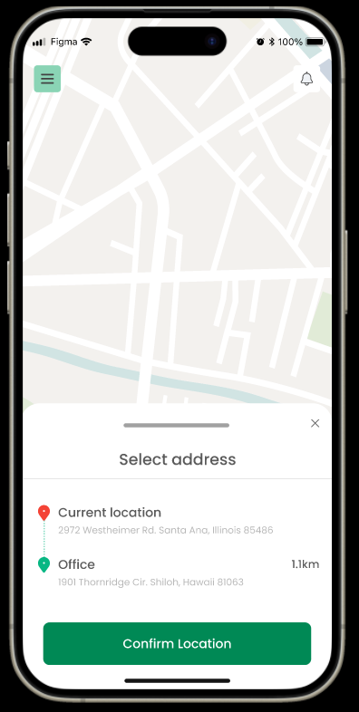

**4.2.16 Payment Method: -**

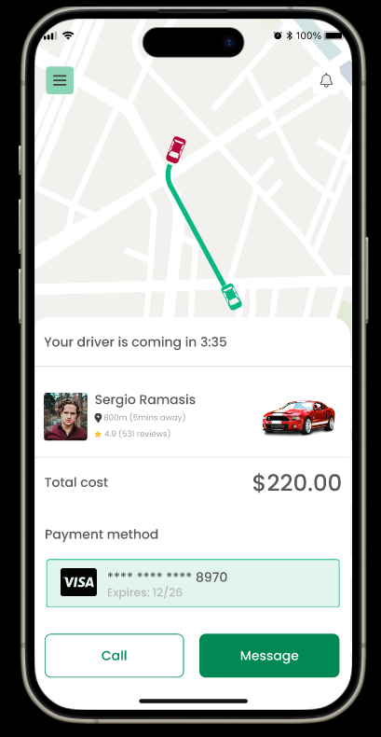

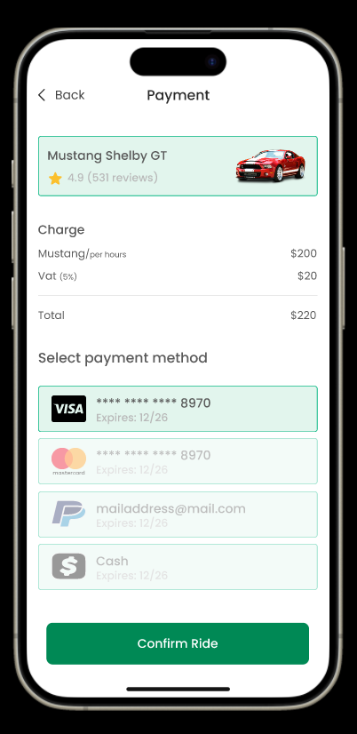

**4.2.17 Payment Success: -**

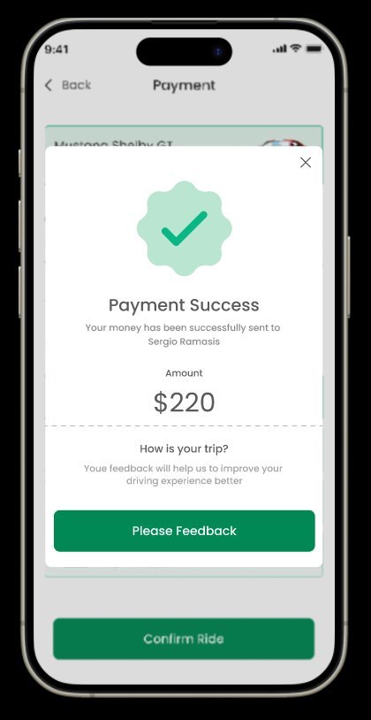

**4.2.18 Document Assistance:**

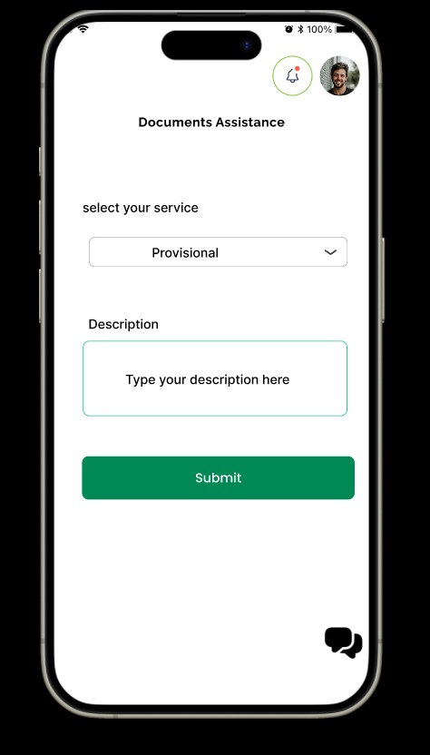

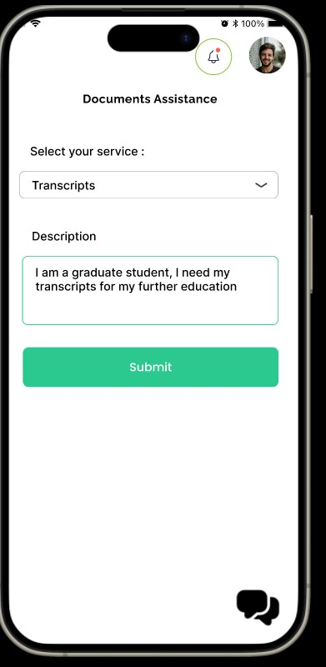

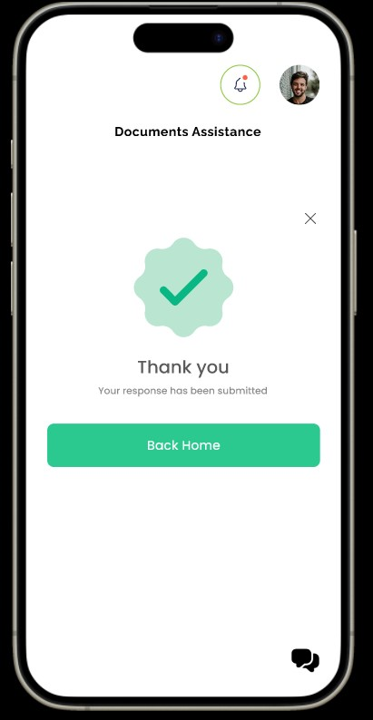

1. Analysis Models
   1. Data Flow Chart

